Chapter 14, Problem 22.

Find the transfer function H(ω) with the Bode magnitude plot shown in
Fig. 14.74.

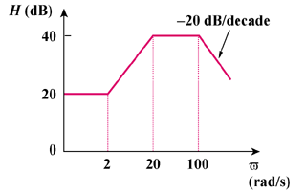
ω
(rad/s)

Figure 14.74
For Prob. 14.22.

